**ELECTRONIC PAYMENT SYSTEM:**

An electronic payment gateway system is a crucial merchant service and technology platform that acts as an intermediary to securely facilitate and authorize online financial transactions, enabling businesses to accept various payment methods like credit cards, debit cards, and digital wallets, and efficiently managing the exchange of funds between customers, businesses, and their respective financial institutions.

Key functions and features of an electronic payment gateway system:

* **Secure Transaction Processing:**

Gateways encrypt sensitive payment information, transmit it to the acquiring bank or payment processor for authorization, and then communicate the transaction status (approved or declined) back to the business's website or app.

* **Security Measures:**

To protect data and prevent fraud, payment gateways utilize security protocols like SSL/TLS, fraud-detection algorithms, and checks like AVS (Address Verification System) and CVV (Card Verification Value). They also adhere to strict compliance standards like PCI DSS.

* **Integration with E-commerce Platforms:**

Payment gateways are integrated with websites, mobile apps, and e-commerce platforms through APIs or pre-built plugins, creating a seamless checkout experience for customers.

* **Types of Payment Gateways:**

There are various types of payment gateways catering to different needs, including redirect, hosted, self-hosted, and API-hosted options.

* **Role in E-commerce Growth:**

As e-commerce continues to expand, payment gateways are essential for businesses to provide a secure and efficient online payment experience and to combat increasing cybercrime.

* **Examples:**

Notable payment gateways and services include Stripe, [PayPal](https://www.paypal.com/us/digital-wallet/how-paypal-works), and in Nepal, services like [NIMB Payment Gateway](https://www.nimb.com.np/digital-banking/services/card-services/payment-gateway) and [NOWPayments](https://nowpayments.io/blog/payment-gateway-nepal).

## What is E-Payment or Digital Payment?

E-payments, or [Digital Payments](https://razorpay.com/learn/digital-payments-india-definition-methods-importance/), refer to online transactions between the payer and payee using digital or electronic [payment methods](https://razorpay.com/blog/different-types-of-payment-methods/). These payments facilitate instant money transfers from the comfort of your home, making them convenient and hassle-free.

## What are the Different Types of Electronic Payment Systems?

Various types of [electronic payment systems](https://razorpay.com/blog/electronic-payment-system/) including debit and credit cards are commonly used for online transactions. Virtual payment cards offer a secure payment method without sharing personal information. [Digital wallets](https://razorpay.com/blog/digital-wallet/) provide convenience by storing payment details on a mobile device.

Here are some of the commonly used types of e payment system:

### 1. Debit Cards

Debit cards are an easily accessible payment method for online businesses. Banks widely issue them upon account opening and they are available to most individuals without complex eligibility requirements. In India, the use of debit cards for transactions has been increasing steadily in recent years. As of January 2023, there are over 945 million active debit cards in India, indicating a growing trend for transactions.

#### ****Advantages of Debit Card Payments****

Debit card payments offer several advantages for both vendors and customers. For vendors, debit card payments ensure funds are transferred directly from the customer’s account. This eliminates the risk of [bounced cheques](https://razorpay.com/learn/cheque-bounce-meaning-and-consequences/) or delayed payments. Additionally, accepting debit cards saves time as there is no need to handle cash or wait for [cheques](https://razorpay.com/learn/what-is-cheque/) to clear.

#### ****Disadvantages of Debit Card Payments****

Debit cards offer convenience and cost-effectiveness similar to credit cards. However, they have limited buyer protection compared to credit cards. Vendors also incur slightly lower costs when accepting debit cards than credit cards. While debit cards are widely accepted, businesses need to consider the level of protection and costs associated with these types of e-payment systems.

### 2. Credit Cards

Credit cards have become a preferred method for companies to pay suppliers due to their convenience and flexibility, and has become one of the most popular types of e payment system. Credit cards have evolved to offer revolving credit lines, allowing cardholders to manage online payments more effectively. To facilitate credit card payments, businesses use merchant accounts and [payment gateways](https://razorpay.com/payment-gateway/) which provide all-in-one solutions like Razorpay or simplified processing tools like Paypal. These electronic payment methods enable seamless transactions, making it easier for businesses to conduct online transactions securely.

#### ****Advantages of Credit Card Payments****

Credit cards are one of the most convenient and widely used types of e-payment systems for supplier payments. They offer various benefits, such as cashback and reward point incentives, optimising cash flow, and quick financing options for small businesses. Accepting credit cards can attract more customers and streamline your payment process.

#### ****Disadvantages of Credit Card Payments****

Merchants often have to pay fees to accept credit card payments, which can eat into their profits. Additionally, businesses may pass these costs onto customers through increased prices or surcharges. Credit card payments are vulnerable to fraud, putting both businesses and customers at risk.

### 3. Virtual Payment Cards

While only 4% of companies prefer virtual payment cards as a supplier payment option, they offer unique benefits. Virtual cards provide enhanced security by generating a unique card number for each transaction, thus protecting against fraud. Additionally, they streamline the payment process by eliminating the need for physical cards and reducing administrative costs.

#### ****Advantages of Virtual Payment Cards****

Virtual payment solutions, like Stampli Card, offer customisable cards with specific spending amounts. This minimises the risk of fraud and unauthorised transactions. These virtual payment cards help companies manage expenses and reduce the chances of unauthorised spending. With this level of customisation and control, businesses can have peace of mind regarding their electronic payment methods.

#### ****Disadvantages of Virtual Payment Cards****

Smaller companies may need help in educating suppliers about the different types of e-payment systems. Only some suppliers are familiar with virtual payment cards. However, virtual payment solution providers can assist in this regard. They can help businesses onboard and educate their suppliers about the benefits of electronic payment methods such as virtual payment cards. By partnering with these providers, businesses can ensure a seamless transition to electronic payments and enjoy enhanced security, convenience and cost savings.

### 4. Digital Wallets

Digital wallets are becoming increasingly popular as a convenient and secure electronic payment method. They allow you to store payment information securely on your smartphone or other digital devices, making online transactions quick and hassle-free.

#### ****Advantages of Digital Wallets****

[Digital wallets](https://razorpay.com/learn/types-of-digital-wallets/) have gained widespread adoption, with billions of payments being made annually. These e-wallets offer various functions such as in-store, online and peer-to-peer payments, in addition to loyalty card storage, and more. With improved broadband availability and the expansion of the Internet of Things (IoT), digital wallet usage is expected to grow. This will lead to more prominent device compatibility for payment acceptance.

#### ****Disadvantages of Virtual Payment Cards****

Implementing [point-of-sale (POS) transactions](https://razorpay.com/blog/what-is-pos-point-of-sale/) with digital wallets can be challenging, especially for online stores or mobile apps that require additional coding. However, digital wallet providers are working to streamline this process by offering simplified integration options. You can now make payments with a simple button press, making the checkout experience seamless and convenient.

### 5. ACH (Automated Clearing House) Payments

[ACH](https://razorpay.com/blog/business-banking/ach-transfers/) is commonly associated with direct deposits but has a broader use for e-cheques. E-cheques are processed securely and quickly through ACH primarily over the Internet, phone or fax. Businesses benefit from e-cheques as they are quicker and safer than traditional paper cheques, and have lower processing costs than paper cheques and credit cards.

#### ****Advantages of ACH Payments****

E-cheques are a faster and safer payment option, with lower processing costs than paper cheques. They offer convenience for both customers and businesses, eliminating the need for physical cheques and manual processing. E-cheques are especially suitable for vendors who prefer cheques as payment, as they can be easily integrated into existing cheque-based accounting systems.

#### ****Disadvantages of ACH Payments****

One of the risks associated with e-cheques is the potential for fraud. Since e-cheques require banking information, there is a higher exposure to fraudulent activity than other payment methods. Additionally, e-cheques may have slower processing times than modes like credit / debit cards, which can be a drawback for businesses that require faster transactions. Considering these factors is important when choosing this electronic payment method for your business.

### 6. Bank Transfers

You can make payments through bank transfers via bank routing and account numbers. Businesses can initiate bank transfers on behalf of customers, often using a reference number. Bank transfers encompass various electronic transfer types like [ACH](https://razorpay.com/blog/business-banking/ach-transfers/) and wire transfers, thus offering versatility and security.

***Related Read:***[***ACH vs Wire Transfer: Key Differences***](https://razorpay.com/blog/ach-vs-wire-transfer/)

#### ****Advantages of Bank Transfers****

The main advantage of bank transfers is the assurance of available funds, leading to almost immediate notifications for vendors regarding incoming payments. This allows merchants to manage online payments efficiently and reduces the risk of fraud or insufficient funds. Bank transfers are a reliable and secure method of transferring money electronically.

#### ****Disadvantages of Bank Transfers****

The drawback of potentially longer processing times in this electronic payment method can affect vendors’ budgets. Some payment providers now offer quicker access to funds for certain fees, which may be passed on to vendors or result in increased rates to offset these costs. This can impact the overall cost-effectiveness of using electronic payment systems.

### 7. Mobile Pay

Mobile pay resembles an electronic wallet that securely stores credit card and banking information for seamless transactions. [Mobile payments](https://razorpay.com/learn/mobile-payment/) offer advantages over traditional wallets, especially in the post-COVID world where [contactless transactions](https://razorpay.com/blog/what-is-contactless-payment/) are preferred. Embracing mobile payment options can enhance convenience and security for both businesses and consumers.

#### ****Advantages of Mobile Pay****

Mobile payments offer a convenient solution for remote and on-the-go transactions. This benefits both customers and businesses, providing efficiency and remote payments for accounts payable departments. With mobile payment methods, you can easily manage online payments using [payment links](https://razorpay.com/payment-links/) or integrating a payment gateway into your e-commerce payment system.

#### ****Disadvantages of Mobile Pay****

Mobile payments offer convenience but come with security risks and compatibility limitations. Regular operating system updates are required to stay on top of security issues. Not all vendors accept mobile payments, so businesses should have alternative payment methods in place. These considerations ensure a seamless payment experience for all customers.

## Why E-Payments are Important for Your Business

Adopting electronic payment methods is no longer optional—it’s essential for businesses aiming to stay competitive, cut costs, and enhance efficiency. Here’s why:

### 1. ****Cost Savings****

E payments drastically reduce operational expenses by eliminating the need for manual processes like cheque printing, postage, and handling. For example, an ACH transfer typically costs far less than processing a paper cheque, which can range from ₹15 to ₹50 per cheque. Businesses can also save on banking fees, as many digital payment platforms offer lower transaction charges compared to traditional methods.

Additionally, electronic credit card payments can generate value through cashback programs, rebates, and reduced processing time. By shifting to e-payments, businesses not only save money but also reallocate resources to more strategic activities.

### 2. ****Convenience and Speed****

E-payments simplify the payment cycle by enabling businesses to process transactions anytime, anywhere. Unlike traditional methods, they eliminate delays caused by cheque clearances or bank hours.

* **Same-Day Processing**: ACH transfers and virtual card payments enable same-day or instant settlements, improving cash flow.
* **Vendor Discounts**: Businesses can leverage faster payments to claim early payment discounts from vendors, reducing procurement costs.
* **Recurring Payments**: Automating recurring payments ensures timely disbursements and eliminates manual follow-ups, making the process seamless for both payers and recipients.

This speed and convenience empower businesses to operate efficiently, save time, and focus on growth.

#### 3. ****Enhanced Security****

E-payment systems offer superior security measures that reduce the risks associated with traditional payment methods. For example:

* **Tokenization**: Replaces sensitive credit card data with encrypted tokens, ensuring that intercepted data cannot be exploited.
* **Fraud Detection Systems**: Advanced algorithms and machine learning identify and prevent fraudulent transactions in real-time.
* [**Two-Factor Authentication**](https://razorpay.com/learn/two-factor-authentication-in-payments/)**(2FA)**: Adds an extra layer of protection for both businesses and customers by requiring verification beyond passwords.

By investing in these secure technologies, businesses protect financial data, maintain customer trust, and comply with regulations like [PCI DSS](https://razorpay.com/blog/what-is-pci-dss-compliance/).

#### 4. ****Improved Cash Flow Management****

E-payments enable businesses to monitor and manage their cash flow in real time. With features like instant payment notifications and detailed transaction histories, businesses can track incoming and outgoing payments effortlessly. This visibility helps in better forecasting and decision-making, ensuring financial stability.

#### 5. ****Global Reach and Scalability****

Digital payment systems make it easier for businesses to expand globally by supporting multiple currencies and cross-border payments. For instance, payment platforms like Razorpay and PayPal streamline international transactions, enabling businesses to cater to customers across the world without worrying about exchange rates or high fees.

#### 6. ****Environmentally Friendly****

Switching to e-payments helps businesses reduce their carbon footprint by eliminating the use of paper, ink, and physical transportation required for cheque processing. This aligns businesses with sustainable practices and appeals to eco-conscious customers.

ONLINE CREDIT CARD TRANSACTION

An **online credit card transaction** is a digital process that allows consumers to purchase goods or services over the internet using their credit cards. The transaction begins when the buyer selects the credit card payment option at checkout and enters essential card details such as the card number, expiration date, CVV code, and cardholder name. Once these details are submitted, a secure payment gateway forwards the information to the issuing bank for verification and authorization. Some transactions may also require additional security steps like OTP (One-Time Password) or 3D Secure authentication. If the bank approves the transaction, the payment is processed, and the amount is debited from the user’s credit card account, while the merchant receives confirmation and the funds are credited accordingly.

However, online credit card transactions come with certain limitations. One of the main concerns is **security**—credit card details can be stolen through phishing, hacking, or unsecured websites. Another limitation is the **credit limit**, which restricts users from spending beyond a certain amount. **Internet access** is also essential, meaning users cannot make payments without a stable connection. Additional **fees** such as convenience charges or foreign transaction fees may apply, especially in international transactions. In cases of product returns, **refunds or chargebacks** can take a long time to process. Furthermore, some websites may **reject certain credit cards** or not accept international cards. Lastly, users making international purchases might face **currency conversion charges**, which can make the transaction more expensive than expected. Despite these limitations, credit card payments remain a widely used and convenient option for online transactions.

LIMITATION:

1. **Security Risks** – Card details can be stolen through hacking, phishing, or insecure websites.
2. **Credit Limit Restriction** – Users cannot spend beyond their assigned credit limit.
3. **Card Declines** – Transactions may fail due to incorrect details, expired cards, or bank restrictions.
4. **Hidden Charges** – Extra fees such as service charges, convenience fees, or processing fees may apply.
5. **Internet Dependency** – Requires a stable internet connection to complete the transaction.
6. **Delayed Refunds** – Refunds and chargebacks can take several days or weeks to process.
7. **Limited Acceptance** – Some websites or countries do not accept all types of credit cards.
8. **Currency Conversion Fees** – Extra charges may apply when making international purchases.
9. **Technical Issues** – Server errors or payment gateway failures can cause transaction problems.
10. **Fraudulent Websites** – Users may unknowingly make payments on fake or scam websites.

**💳 Online Stored Value Payment System**

An **online stored value payment system** is a digital method of storing monetary value electronically that can be used for online transactions. The value is **preloaded** into an account or a card, and then used for making payments without involving a direct connection to a bank account each time.

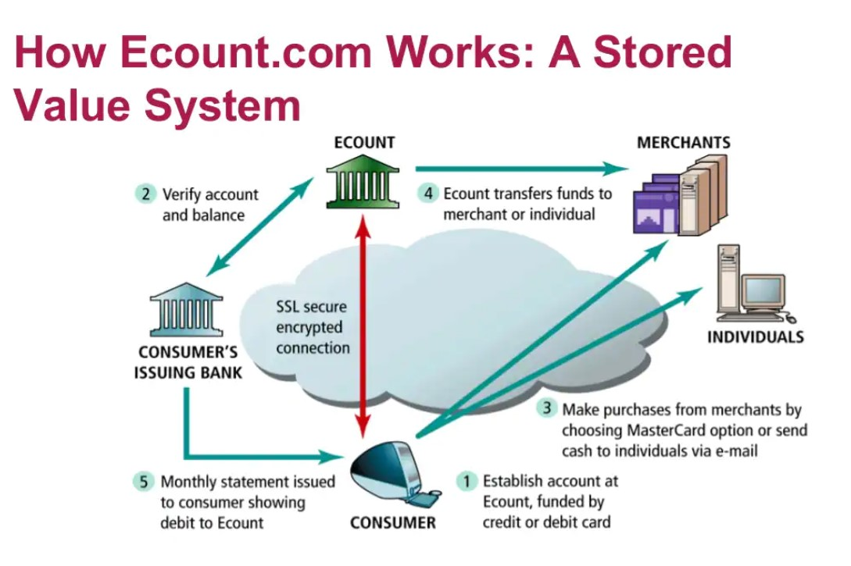

**✅ Definition:**

An online stored value payment system refers to a **prepaid financial service** where users **store money digitally** and use it to pay for goods or services online, often without the need for traditional banking systems during each transaction.

Types of :

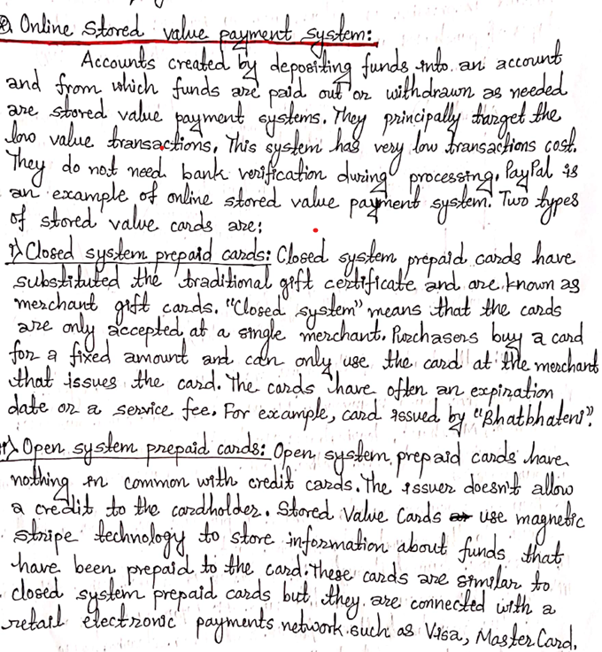

**💡 How it Works:**

1. **Load money** into a digital account or wallet (via bank transfer, credit card, etc.).
2. The stored amount is kept in a secure online system.
3. Users can **spend** this amount to make purchases or transfers.
4. No need to reauthorize or connect to bank for each transaction unless reloading.

**📱 Examples:**

* **Digital Wallets:** PayPal, Google Pay, Apple Pay, eSewa, Khalti (Nepal)
* **Prepaid Cards:** Virtual Visa or Mastercard
* **Gaming Credits:** Steam Wallet, PlayStation Wallet
* **Online Gift Cards:** Amazon gift card balance

**🎯 Features:**

* Instant transactions
* Doesn't require continuous bank access
* Often used for microtransactions or small payments
* Can be used internationally (depending on the provider)

**🔐 Security:**

* Two-factor authentication
* Encrypted storage
* Sometimes limited balance to reduce risk

**📉 Limitations:**

* Limited to the loaded balance
* May have expiration dates or inactivity fees
* Not universally accepted
* Risk of loss if credentials are compromised

**🧾 Uses:**

* Online shopping
* Subscription services
* In-app purchases
* Peer-to-peer transfers
* Paying bills digitally

**Social Mobile Peer-to-Peer (P2P) Payment Systems**

**Social Mobile Peer-to-Peer (P2P) Payment Systems** are platforms or apps that allow users to send and receive money directly from one another using their mobile devices. These systems are integrated with **social features**, making it easy to transact with friends, family, or even small businesses via contacts, chats, or social media platforms.

**✅ Key Features of Social Mobile P2P Payment Systems:**

1. **Mobile Accessibility** – Operates on smartphones via apps.
2. **Instant Transfers** – Sends/receives money instantly between peers.
3. **Social Integration** – Often linked with contacts, chats, or social media accounts.
4. **User-Friendly Interface** – Easy to navigate, even for non-tech users.
5. **Bank or Wallet Linking** – Connects to bank accounts, cards, or digital wallets.
6. **Transaction History** – Records past transactions for tracking.

**📱 Examples of P2P Payment Systems**

| **App Name** | **Country** | **Special Features** |
| --- | --- | --- |
| Venmo | USA | Social feed showing who paid whom (with emojis, notes) |
| PayPal | Global | Linked to email/mobile number, secure transactions |
| Cash App | USA | Bitcoin trading + peer payments |
| Google Pay | Global | Linked to Google account, works with QR & phone |
| Apple Pay | iOS devices | iMessage integration, Face/Touch ID authentication |
| Fonepay/eSewa/Khalti | Nepal | Mobile wallet and bank transfers + utility payments |

**🎯 Advantages**

* Easy and fast money transfers
* Reduces the need for cash
* Ideal for splitting bills, paying friends, etc.
* Secure with OTPs, PINs, and encryption
* Social engagement through comments, reactions

**⚠️ Limitations**

* Requires internet and smartphones
* Risk of scams if sent to the wrong contact
* Limited to regions or certain banks (in some apps)
* Privacy concerns (especially with public feed like in Venmo)

**EBPP** stands for **Electronic Bill Presentment and Payment**. It is a system used in **e-commerce** that allows companies to **send bills (invoices)** to customers electronically and enables customers to **view and pay** those bills **online**.

**Key Features of EBPP:**

1. **Electronic Presentment**: Customers can view their bills through a website, email, or app.
2. **Electronic Payment**: Customers can pay using online methods like debit cards, credit cards, digital wallets, or bank transfers.
3. **Automation**: Reduces the need for paper bills and manual processing.
4. **Security**: Uses encryption and authentication to protect financial information.

**🔹 Types of EBPP:**

1. **Biller-Direct**: Customers log in to the biller's website to view and pay bills (e.g., utility company website).
2. **Bank-Aggregator**: Customers can see and pay bills from multiple billers through their bank's website.

**🔹 Advantages of EBPP in E-commerce:**

* Saves time and cost (no paper or postage).
* Real-time processing of payments.
* Environmentally friendly.
* Easy tracking and management of transactions.
* Reduces errors and late payments.

**Auctioning in E-commerce:**

**Auctioning** in e-commerce refers to a **buying and selling process** where goods or services are sold to the **highest bidder** through **online bidding platforms** within a **specific time period**.

**🔹 Key Features:**

* **Competitive Bidding**: Multiple buyers place bids, and the highest bid wins.
* **Time-Limited**: Auctions usually have a deadline.
* **Online Platform**: Conducted on websites or e-commerce apps (e.g., eBay).

**🔹 Types of E-commerce Auctions:**

1. **English Auction (Forward Auction)**
   * Bidders place increasing bids.
   * Highest bidder wins.
2. **Dutch Auction**
   * Starts with a high price that lowers until a buyer accepts.
3. **Reverse Auction**
   * Buyers post a need, and sellers bid by lowering their prices.
   * Lowest bidder usually wins. Common in B2B.
4. **Penny Auction**
   * Each bid raises the price by a small amount (e.g., $0.01).
   * Participants pay to place each bid.

**🔹 Advantages:**

* Efficient price discovery.
* Greater reach to global buyers/sellers.
* Transparency and competition.
* Can maximize profit for sellers.

**🔹 Example:**

* A seller lists a smartphone on eBay.
* Bidders place increasing bids for 3 days.
* The highest bidder at the end of the auction gets the phone.

## Secure Electronic Transaction(SET)

  SET is a security protocol designed to ensure the security and integrity of electronic transactions conducted using credit cards. Unlike a payment system, SET operates as a security protocol applied to those payments. It uses different encryption and hashing techniques to secure payments over the internet done through credit cards. The SET protocol was supported in development by major organizations like Visa, Mastercard, and Microsoft which provided its Secure Transaction Technology (STT), and Netscape which provided the technology of Secure Socket Layer (SSL).   
  
SET protocol restricts the revealing of credit card details to merchants thus keeping hackers and thieves at bay. The SET protocol includes Certification Authorities for making use of standard Digital Certificates like X.509 Certificate.

Before discussing SET further, let's see a general scenario of electronic transactions, which includes client, payment gateway, client financial institution, merchant, and merchant financial institution.

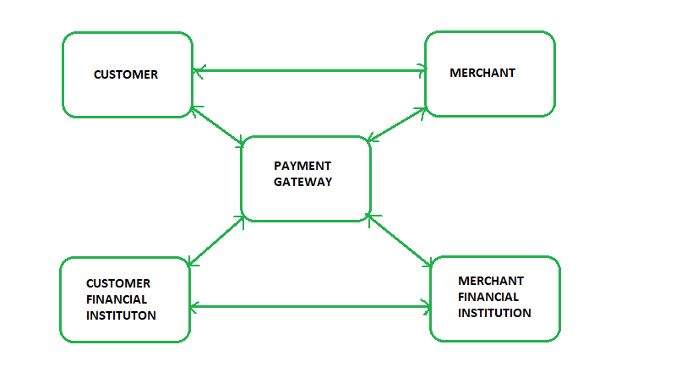

**Requirements in SET:** The SET protocol has some requirements to meet, some of the important requirements are:

* It has to provide mutual authentication i.e., customer (or cardholder) authentication by confirming if the customer is an intended user or not, and merchant authentication.
* It has to keep the PI (Payment Information) and OI (Order Information) confidential by appropriate encryptions.
* It has to be resistive against message modifications i.e., no changes should be allowed in the content being transmitted.
* SET also needs to provide interoperability and make use of the best security mechanisms.

**Participants in SET:** In the general scenario of online transactions, SET includes similar participants:

1. **Cardholder -** customer
2. **Issuer -** customer financial institution
3. **Merchant**
4. **Acquirer -** Merchant financial
5. **Certificate authority -** Authority that follows certain standards and issues certificates(like X.509V3) to all other participants.

**SET functionalities:**

* **Provide Authentication**
  + **Merchant Authentication** - To prevent theft, SET allows customers to check previous relationships between merchants and financial institutions. Standard X.509V3 certificates are used for this verification.
  + **Customer / Cardholder Authentication** - SET checks if the use of a credit card is done by an authorized user or not using X.509V3 certificates.
* **Provide Message Confidentiality**: Confidentiality refers to preventing unintended people from reading the message being transferred. SET implements confidentiality by using encryption techniques. Traditionally DES is used for encryption purposes.
* **Provide Message Integrity**: SET doesn't allow message modification with the help of signatures. Messages are protected against unauthorized modification using RSA digital signatures with SHA-1 and some using HMAC with SHA-1,

**Dual Signature:** The dual signature is a concept introduced with SET, which aims at connecting two information pieces meant for two different receivers :

**Order Information (OI) for merchant**   
**Payment Information (PI) for bank**

You might think sending them separately is an easy and more secure way, but sending them in a connected form resolves any future dispute possible. Here is the generation of dual signature:

HOW SET PROTOCOL WORKS:

**SET (Secure Electronic Transaction) Protocol Working Steps:**

1. **Initiation of Transaction:**
   * The customer selects the goods/services and proceeds to checkout.
2. **Cardholder Authentication:**
   * The cardholder (customer) uses a **digital certificate** issued by a trusted authority to prove identity.
3. **Order and Payment Information Creation:**
   * The order information (visible to the merchant).
   * The payment information (visible only to the bank).
   * Both are combined using a **dual signature** that ensures integrity and confidentiality.
4. **Encryption of Payment Information:**
   * The payment information is encrypted using the bank’s public key.
   * Order information is sent in plain text to the merchant.
5. **Sending to Merchant:**
   * The cardholder sends both the **order information** and **encrypted payment information** with a digital signature to the merchant.
6. **Forwarding to Payment Gateway:**
   * The merchant forwards the **encrypted payment information** and **order details** to the payment gateway (acquiring bank).
7. **Verification by Payment Gateway:**
   * The payment gateway verifies:
     + The customer’s digital signature.
     + The merchant’s certificate.
     + Payment authorization from the issuing bank.
8. **Transaction Approval:**
   * If valid, the issuing bank authorizes the payment and sends approval to the payment gateway.
9. **Confirmation to Merchant:**
   * The payment gateway informs the merchant of successful payment authorization.
10. **Order Confirmation to Cardholder:**
    * The merchant confirms the order to the customer.

**Key Features of SET Protocol:**

* Dual Signature (to protect both order & payment info).
* Digital Certificates (for authentication).
* Encryption (for secure data transfer).
* Payment Authorization handled by the bank, not by the merchant.

PHASES OF SET PROTOCOLS:

**Phases of SET (Secure Electronic Transaction) Protocol:**

1. **Cardholder Registration Phase:**
   * The cardholder registers with the **Certificate Authority (CA)**.
   * The CA issues a **digital certificate** to the cardholder.
   * This certificate confirms the identity of the cardholder for future transactions.
2. **Merchant Registration Phase:**
   * The merchant registers with the **Certificate Authority (CA)**.
   * The CA issues a **digital certificate** to the merchant.
   * This proves the merchant is authorized to accept payments.
3. **Purchase Request Phase (Ordering Phase):**
   * The cardholder creates the **Order Information (OI)** and **Payment Information (PI)**.
   * The **Dual Signature** is created to link both OI and PI securely.
   * The PI is encrypted with the **payment gateway’s public key**.
   * The cardholder sends OI + encrypted PI + dual signature to the merchant.
4. **Payment Authorization Phase:**
   * The merchant forwards the encrypted PI to the **Payment Gateway**.
   * The Payment Gateway decrypts and verifies the payment.
   * The Payment Gateway requests **authorization** from the issuing bank.
   * Once authorized, the Payment Gateway informs the merchant.
5. **Payment Capture Phase:**
   * After the product is shipped/delivered, the merchant requests the Payment Gateway for payment capture.
   * The Payment Gateway sends a **capture request** to the issuing bank.
   * The bank transfers the funds to the merchant’s account.

**Summary of SET Phases in Points:**

* ✅ Cardholder Registration
* ✅ Merchant Registration
* ✅ Purchase Request (Order & Payment Information)
* ✅ Payment Authorization
* ✅ Payment Capture

**Dual Signatures (in SET Protocol):**

* **Purpose:** To protect both **Order Information (OI)** and **Payment Information (PI)**.
* Ensures that:
  + The **merchant** sees the **order details** but cannot read the **payment information**.
  + The **bank** sees the **payment information** but cannot read the **order details**.
* **How it works:**
  + The cardholder creates hashes of both OI and PI.
  + Both hashes are combined and encrypted with the cardholder's **private key** to create the **dual signature**.
  + The dual signature ensures:
    - **Data Integrity**
    - **Authentication**
    - **Non-repudiation**

**2️⃣ Virtual Currency (Digital Currency):**

* **Definition:**  
  A **virtual currency** is a type of digital currency that exists only in electronic form and is not issued by any central authority (like a government or central bank).
* **Examples:**
  + Bitcoin
  + Ethereum
  + USDT (Tether)
  + In-game currencies (like PUBG UC, Free Fire Diamonds)
* **Features:**
  + Operates on **blockchain** or decentralized networks.
  + Used for **online transactions**, investments, and trading.
  + Can be exchanged for real money (in some cases).
  + Not physical — exists only in **digital wallets**.
* **Common Uses:**
  + Online purchases
  + Peer-to-peer payments
  + Investment and trading (cryptocurrency exchanges)

**Status of E-Payment System in Nepal (as of 2025):**

* The **E-payment system in Nepal** has seen significant growth, especially after COVID-19.
* Digital wallets, mobile banking, internet banking, QR payments, and online gateways are widely used.
* **Nepal Rastra Bank (NRB)** promotes digital payment by issuing guidelines and licenses.
* Popular payment service providers (PSPs):
  + **eSewa**, **Khalti**, **IME Pay**, **Prabhu Pay**, **Fonepay**
* Banks are integrated with **Fonepay** and **NCHL Connect IPS** for interbank payments.
* QR-based payments and mobile apps are used by small and large businesses.

**Functions of E-Payment System in Nepal:**

1. **Fund Transfer:**  
   Transfer money between bank accounts, wallets, or between users.
2. **Utility Bill Payments:**  
   Pay electricity, water, internet, and other utility bills online.
3. **Merchant Payments:**  
   Pay for goods and services using QR code scanning or online checkout.
4. **Mobile Recharge & Top-up:**  
   Recharge mobile balance and purchase data packages.
5. **Government Services Payments:**  
   Pay taxes, fines, passport fees, etc.
6. **Remittance Services:**  
   Receive and send remittances digitally.
7. **Online Shopping & E-commerce Payments:**  
   Payment gateways for online shopping sites.

**Merits of E-Payment System in Nepal:**

* ✅ **Convenience:**  
  Pay anytime, anywhere — saves time and effort.
* ✅ **Fast & Secure Transactions:**  
  Instant payment with security through OTP, PIN, and biometrics.
* ✅ **Reduced Cash Handling:**  
  Promotes cashless economy, reducing the risk of theft and fraud.
* ✅ **Supports Financial Inclusion:**  
  Provides banking access to people in remote areas through mobile apps.
* ✅ **Cost-Effective:**  
  Low or no transaction fees compared to traditional methods.
* ✅ **Record Keeping & Transparency:**  
  Digital records of all transactions help in tracking expenses.

**E-Cash (Electronic Cash):**

* **Definition:**  
  E-Cash is a form of **digital money** used for online transactions, designed to work like physical cash in electronic form.
* It is a **prepaid, anonymous, and transferable** electronic payment system.
* Users withdraw E-Cash from their bank and store it in digital wallets for making online purchases.
* **Developed Concept:**  
  Proposed by **David Chaum** in the 1980s with a focus on **privacy** and **security**.

**✅ Key Properties of E-Cash:**

1. **Anonymity:**
   * Like physical cash, e-cash transactions can be made without revealing the identity of the user.
   * Protects user privacy.
2. **Security:**
   * Encrypted using cryptography.
   * Cannot be duplicated or tampered with.
3. **Divisibility:**
   * Can be split into smaller units (like coins and notes).
   * Users can make payments of any amount.
4. **Transferability:**
   * Can be transferred from one user to another without the involvement of a third party.
5. **Portability:**
   * Can be stored in smart cards, digital wallets, or devices, making it easy to carry.
6. **Unforgeability:**
   * Cannot be forged due to cryptographic protection.
7. **Double Spending Prevention:**
   * Ensures that the same e-cash cannot be spent more than once.
   * Verified by the issuing authority or system.
8. **Acceptance by Merchants:**
   * Accepted by online merchants who recognize the issuing bank or system.

**✅ Example Systems:**

* DigiCash (first concept)
* BitCoin (modern digital cash with decentralized control)